**Lab 5**

**Name:** Etcherla Sai Manoj **Mis. No:** 112015044 **Branch:** CSE

**Question1:**

**Code:**

#include<iostream>

using namespace std;

class Time{

int hrs, min;

public:

void display(){

cout << "Hours : " << hrs << endl;

cout << "Minutes : " << min << endl;

}

void operator=(int d){

// Basic type ==> Class Type Conversion

hrs = d / 60;

min = d % 60;

}

};

int main(){

Time t1;

int period;

cout << "Enter time duration in minutes : ";

cin >> period;

// // Basic type ==> Class Type Conversion

t1 = period;

t1.operator=(period);

t1.display();

return 0;

}

**Input & Output:**

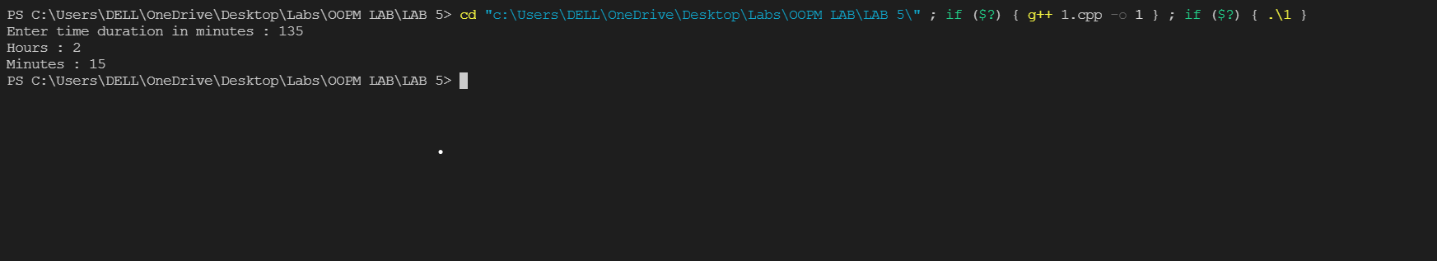

**Question2:**

**Code:**

#include<iostream>

using namespace std;

class Time{

int min;

public:

Time(){

cout << "Enter minutes : ";

cin >> min;

}

operator int(){

// Class Type ==> Basic Type Conversion

if(min > 60){

int h = min / 60;

min = min - (h*60);

return h;

}

else{

int m = min % 60;

return m;

}

}

~Time(){

};

};

int main(){

Time t1;

int hours, minutes;

// Class Type ==> Basic Type Conversion

hours = t1.operator int();

minutes = t1.operator int();

cout << "Hours : ";

cout << hours << endl;

cout << "Minutes : ";

cout << minutes << endl;

return 0;

}

**Input & Output:**

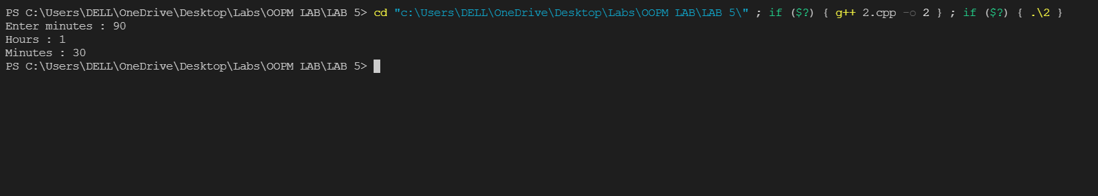

**Question3:**

**Code:**

#include<iostream>

using namespace std;

class Time{

int min;

public:

Time(int a){

min = a;

}

int get_duration(){

if(min > 60){

int h = min / 60;

min = min - (h*60);

return h;

}

else{

int m = min % 60;

return m;

}

}

void display(){

cout << "\nTotal Minutes : " << min << endl;

}

};

class Minutes{

int h, m;

public:

Minutes(){

h = 0; m = 0;

}

void operator=(Time t){

h = t.get_duration();

m = t.get_duration();

}

void display(){

cout << "Hours : " << h << endl;

cout << "Minutes : " << m << endl;

}

};

int main(){

int hours, minutes;

cout << "Enter Minutes : ";

cin >> minutes;

Time t1(minutes);

Minutes m1;

// Class Type ==> Class Type conversion

// Time Class ==> Minute Class Conversion

m1 = t1;

t1.display();

m1.display();

return 0;

}

**Input & Output:**

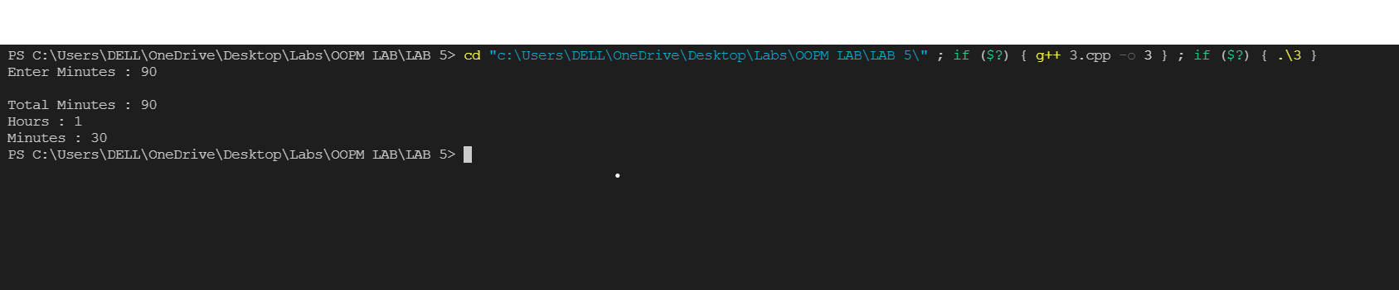

**Question4:**

**Code:**

#include<iostream>

using namespace std;

//Base class

class College{

public:

void display(){

cout << "\n*******Demonstration of Inheritance******" << endl;

cout << "Base class called using object of Derived class\n" << endl;

}

};

// Derived class

class Student : public College{

};

int main(){

Student s1;

// calling a member function from Base Class

s1.display();

return 0;

}

**Input & Output:**

